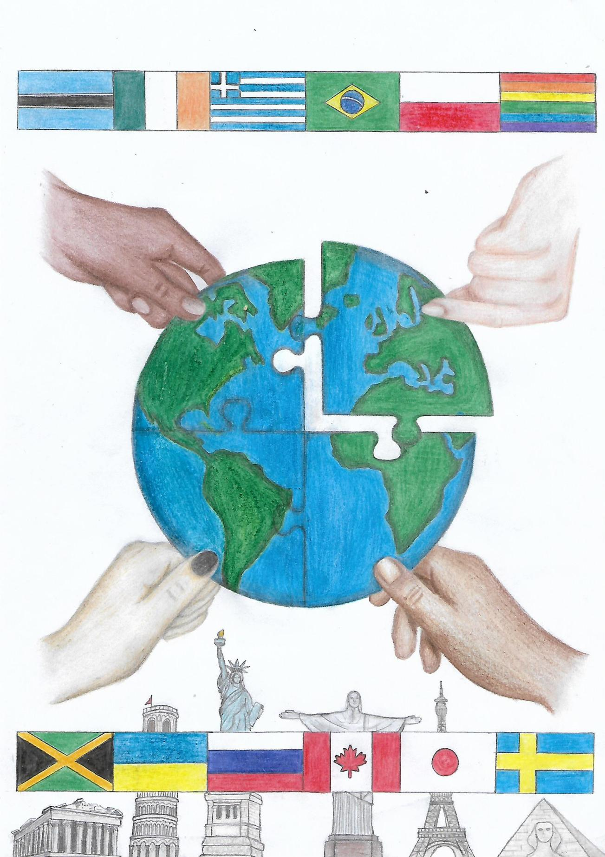
Youth Voice
ENGLISH SCHOOL NEWSPAPER

13th Edition
School year 2022-23
1st Junior High School of Trikala

CONTENTS

- Gender Equality by Zoe Dode p.3
- Respect to diversity by Konstandina Aggeli p.4
- No Poverty by Olympia Liagoumi p.4
- No Poverty by Theodora Topouzi-Eleni Kombolia p.5…
- No Poverty by Rania Anagnostopoulou p.5
- Zero Hunger – Famine by Christos Karanasios p.5
- Education Inequality by Magda Karageorgou p.7
- Quality Education by Konstantina Ioanna Mantzana p.8
- Quality Education by Christina Varsami p.8
- Quality Education as a sustainable development goal by Christina Varsami p.9
- Protecting the Environment by K. Gouzioti, C. Malakassioti, M. Lipa p.10
- Our polluted planet by Artemis Manitsa p.10
- Food and good health by Zoe Bihta p.10

GENDER EQUALITY
Gender equality is an issue that has been troubling our society for quite a long time. All individuals should be considered equal no matter what their race, colour, class or more specifically gender is. Both men and women should be able to participate actively in public and private life.
Although gender is defined by the same empowerment, responsibility and the ability to engage in everything, a great deal of violence and discrimination exist to prove that the traditional roles of men and women can not yet be fully challenged. Especially women’s human rights are not completely clear.
To begin with, an important aspect to discuss further, is women’s economic independence. There have been thousands of cases where women have reported an indirect sense of authority by male colleagues or superiors. To make matters worse, this roots back to the education system, which in combination to the text books fail to promote the female contribution to science, history, politics or arts, thus fail to offer an opportunity of empowerment to female students. The old fashioned social structure placed women in the house, taking care of the family, struggling to become better wives and mothers . In contrast, men were more present in the public sphere trying to earn more money or claiming a higher position in the society.
Nowadays though, young girls and women are seeking economic independence before they start a relationship, or finally get married. This gives them power and confidence to stand against oppression and are not afraid to make their own decisions for their own future. No male presence in their lives defines their position and status, as equal members of our community. There have been numerous brave women during the past decades who bravely stood up for their rights, ignoring the principals of men superiority and the consequences that would follow in their attempt to pave the way for equality. They started from professions like caregivers, teachers and nurses, to enter the workforce. After a while, they managed to facilitate their equal rights in education, which helped them acquire a university degree and claim job positions, like doctors, lawyers, even managers and judges. Today, we have women, who lead their own lives, totally independent, socially and financially, who can even be single mothers. However, a lot of them still deal with gender discrimination in the working environment in their neighborhood or even in their network.
All in all, gender equality has been and still is an open wound for our society, which discourages the recognition of the value of women in general. Thus , any kind of discrimination does not allow any further growth. It is vital that we promote gender equality from the first year of school, inside the family environment and spread knowledge on this matter to create a beautiful world for all of us.
ZOE DODI C5
RESPECT TO DIVERSITY
Diversity is a multidimensional word; diversity can exist because of origin, because you are disabled, because of age, gender, colour , religion, social status and other factors.
But in all those, there is a common factor, the individual, his values, his needs, his anxieties. Humans adopt, from a very young age, stereotypes and prejudices. Being different is somewhat difficult to accept and considered otherwise dangerous. On the contrary, being similar is considered safe and as a consequence is generally accepted. This is how categories of people are created where certain characteristics are attributed. As a result, people experience social exclusion once again.
But at some point, this has to stop! We have to see matters and people from a different perspective. We must respect people, we must listen and learn because ignorance causes audacity. It is wiser to think before judging others. What we hate, should not be done to others. Human privacy should be respected and not offended. True value is not found in the external appearance of a person , but in mental maturity and moral life.
We are all different from one another, but we also need each other’s respect and acceptance. That’s why we accept that diversity enriches society and makes it a beautiful place to live in.
KONSTANDINA AGELI C3
NO POVERTY
Why are there so many people who are suffering from poverty in the 21st century ?? This is a question that bothers millions of people. Some could say that the evolution in many fields of everyday life would lower the percentage of poverty , but nothing really changes.
Poverty is caused from a lot of causes, like unemployment, social status, natural disasters and many more. In our days, Covid-19 pandemic seems to deteriorate these causes , giving to the world population a boost to be poorer than before.
The ‘face’ of poverty is cruel, depriving basic goods and needs for people. Water, food, shelter, medication should be a datum. Also, education is a most significant need for people. Everyone should have this privilege.
The younger generation , with the help of the older generation, have the chance to try and change this unpleasant and unfair situation. Social, political and communal changes should be made and supported by everyone.
Moreover, governments should pose the rightful conditions for productive employment, give job opportunities and educate young people. The most important is hope to be given to those who experience difficulties, so as to have a brighter future.
OLYMPIA LIAGOUMI C5
NO POVERTY
When we refer to poverty, we mean the economic situation of some people, who cannot acquire the necessary goods we need to live. Specifically, poverty prevails in Third World countries, where families struggle for their lives.
Poverty in Europe is defined as the percentage of the population living with an income below 60 per cent of the middle income . In Greece, this percentage exceeds 20 per cent. The region with the greatest poverty is Epirus with Eastern Macedonia-Thrace, while the regions with the lowest are Attica and Crete.
The risk of poverty is greater for people with a low level of education and for household with a large number of members. Poverty, at an individual level, can be related to low retirement and unemployment.
THEODORE TOPOUZI ELENI KOMBOLIA A4
NO POVERTY
Almost one billion people are currently suffering from poverty. This is neither natural nor accidental. Poverty does not arise from lack of wealth, but from unequal distribution, and its causes stem from the denial marginalization of human rights.
There are ways to fix it. First, we can all help alleviate this problem. These are some ways:
- In cooperation with the other members of the community, that is, the members who have the financial ability to contribute even a little, we can organize various events that support the people who suffer from this problem. Charity events could be organized to provide support, food, clothing, money etc.
- Organizations of Nations for gathering food and other necessary help.
- Through donations, both from the church and from citizens, which is a frequent form of dealing with this specific problem, because the necessary material goods gathered will be distributed to the people in need.
The above are some ways of dealing with the problem of poverty. If the above is done, most of the poverty around the world will be eliminated.
Rania Anagnostopoulou C1
ZERO HUNGER- FAMINE
In the 21st century , which is full of technological inventions and scientific miracles, societies worldwide are still wondering about famine and the ways to improve the kind of help we give to famine victims.
The way I see it, the aid we offer to famine victims at the moment, is simply not sufficient. This is partly due to the fact that there is not enough money available for famine relief and current supplies of food and medicine are being wasted or stolen. Famine victims need permanent solutions, as well as immediate.
To begin with, much more money could be raised by holding charity concerts and other money raising events. In this way, international organizations would receive the money they need to provide emergency famine relief and be able to save thousands of lives.
Another way of helping victims would be for wealthy countries to send food and medical supplies directly to areas affected by famine. What is more, by improving administration and transport, supplies would be certain to reach those people who really need help.
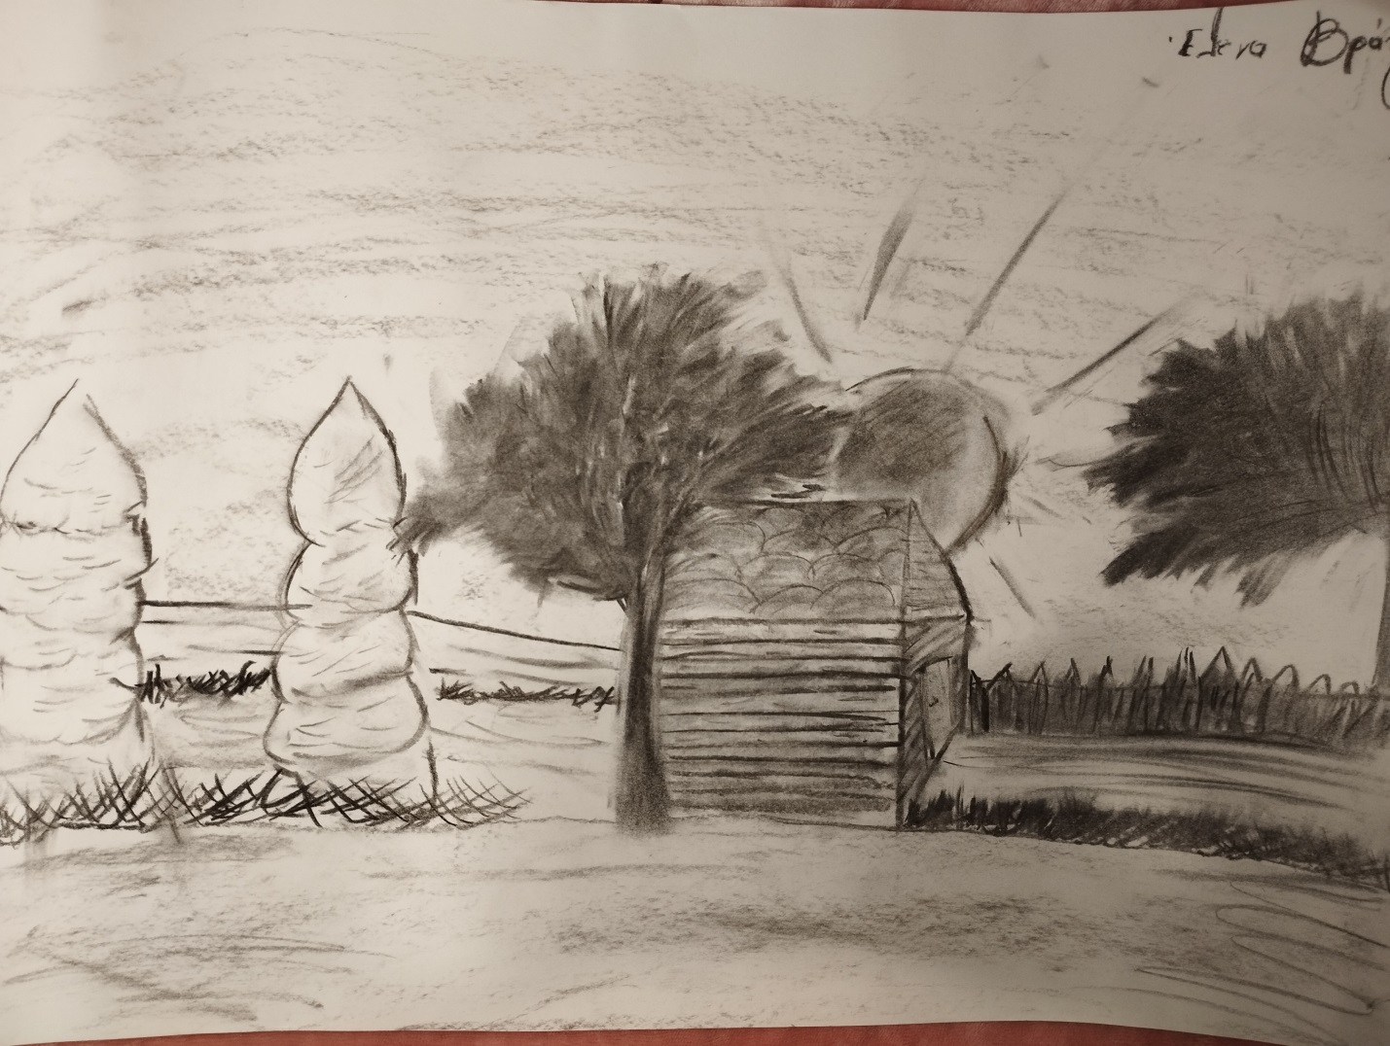
Picture made by Eleni Vrantza

Another solution would be to educate farmers in famine areas , so that they could improve their farming techniques, making sure that famine is less likely to occur in the future. Additionally, in order to solve famine disasters in the third world countries, the rest of the world should provide them with financial aid they need to build expensive, irrigation systems. Consequently, they would be able to grow their own crops successfully and increase their food supplies.
Taking everything into account, it is extremely difficult to solve the problem of famine. If, however, the matter is taken seriously and world leaders join together to find solutions, the situation can be improved.
CHRISTOS KARANASIOS C5
EDUCATION INEQUALITY
Education is the key for a better future. It can provide people with new chances for a good job position and financial security. It can also help them develop their communication skills, as well as their critical and logical thinking. More generally, well educated people are more likely to ensure a better lifestyle and therefore, a better future. This is also proved by an activist named Malcolm X, who claimed: “Education is the passport to the future, for tomorrow belongs to those who prepare for it today.”
From the above mentioned, it goes without saying that education is of significant importance to everyone and especially to the younger generation. Still, a huge number of people take it for granted, but unfortunately it is not. There are a lot of countries who can’t or won’t provide their citizens with proper education. You would be surprised that over 600 million children and adolescents worldwide are unable to attain minimum proficiency levels in reading and mathematics, even though two thirds of them are in school. Some examples of countries all around the world with illiteracy is Nigeria, Sudan, Comoros, Iraq, Afganistan, Mali and many more. These unequal educational outcomes are attributed to several variables, including family of origin, gender, and social class. Achievement, earnings, health staus, and political participation also contribute to educational inequality. It’s unacceptable if not sad that still in the year 2023 there are people out there who don’t even know how to read and write.
Therefore, we should be glad that we are able to educate ourselves but we should also try to help others who don’t have that luxury by donating books, money, school supplies etc. This is a serious, social matter and it is rightfully one of the 17 Sustainable Development Goals, which are the blueprint to achieve a better and more sustainable future for all. They address the global challenges we face, including poverty, inequality, climate change, environmental degradation, peace and justice. So, learn more and take action because providing quality education for all is fundamental to creating a peaceful and prosperous world.
MAGDA KARAGEORGOU C5

QUALITY EDUCATION
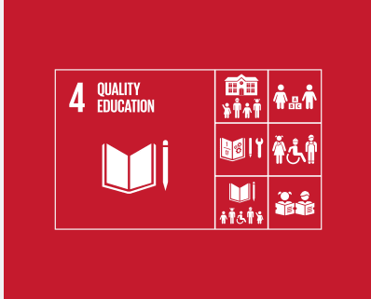
Quality Education is one of the 17 goals of sustainable development of the United Nations.The school systems, in Africa and Southern American countries is almost non- existent. Most of the time students will be lucky to even step a foot in a school. More than half of the population is uneducated. What’s even more horrendous is that around 63% of that population is women. The main reason for that is the country’s poverty. The government is unable to provide the necessaries such as an appropriate work place, hiring good educators and proper books that actually have good content. The most effective way this could be solved is either by encouraging other countries to donate or raising funds. That way, the citizens can stand on their feet and start off by constructing school buildings and so on.
KONSTANTINA IOANNA MANTZANA A2
QUALITY EDUCATION
Quality education is an important development goal for many countries, as well as one of the main purposes of the United Nations. Yet, 66 million primary school children go to school hungry, 23 million of them in Africa. And these are one of the problems that contribute to the poor quality education of students in Africa and worldwide. Students in countries such as Burundi, the Central African Republic and Ethiopia still lack access to equal the quality education. The problem in the region is so severe that these low income countries are not projected to reach global levels of basic education before 2100-100 later than higher income countries. Solving the problem of quality education in Africa is a burning issue as according to UNESCO estimates, it would reduce maternal mortality by 70 per cent in Saharan Africa if women completed primary school, while at the same time almost 60 per cent fewer girls would become pregnant under the age of 17, if they finished high school. In other words, one notices that apart from the hunger that poverty can cause, the contribution to a better way of education can help to solve other problems such as the reduction of maternal mortality..
Quality Education as a Sustainable Development Goal
Acquiring quality education is the basis for improving human life and sustainable development. Significant progress has been made in terms of access to education at all levels and schooling for women and girls. Basic reading and writing skills have improved tremendously. However, bolder efforts are needed to realize the goal of universal education. According to goal 4 of the United Nations Organization, the goal of pursuit is to ensure the completion of education, that is, that by 2030, all boys and girls will complete primary and secondary education freely, equally, and with quality, reaping the learning benefits described in this goal.
CHRISTINA VARSAMI C5
PROTECTING THE ENVIRONMENT
Nowadays, it is a well-known fact that the environment is under threat, so more and more people are going green in an effort to protect it. There are different ways to help our planet, but the first and simplest is by reducing waste at home.
First of all, making a weekly meal plan is a practical way to produce less household waste. What I mean is that we can decide in advance which dishes we want to eat on each day of the week and only buy the products we need to prepare them. In this way, smaller amounts of food will end up in rubbish bins.
In addition, we can make our own cleaning products, instead of getting them from the supermarket. For example, we can make natural ingredients, such as vinegar and lemon and use them to clean the kitchen and bathroom and get rid of all those plastic containers .In this way, the environment will not be polluted by harmful chemicals.
All in all, protecting the environment begins from our own home. If each one of us follows just a few easy steps, we can help save our planet.
KONSTANDINA GOUZIOTI A1, CHRISILIA MALAKASSIOTI A1,
MICHAELLA LIPA A1
OUR POLLUTED PLANET
Have you ever thought that the plastic you throw away could make its way into the sea? Once plastic is in the ocean, it decomposes very slowly, breaking into tiny pieces known as microplastics, which can enter the marine food chain and become incredibly damaging to sea life.
You might think that you are always recycling the plastic you have, but sometimes, when rubbish is being transported to landfills, plastic is often blown away because it is so lightweight. From there, it can eventually clutter around drains and enter rivers and the sea. What is more, litter dropped on the street doesn’t stay there. Rainwater and wind carry plastic waste into streams and rivers and through drains, which end up in the ocean.
Many products we use daily are flushed down the toilets, including wet wipes, cotton buds and sanitary products. Microfibres are even released into waterways when we wash our hands and clothes. They are too small to be filtered out. Water plants end up being consumed by small marine species. Eventually it ends up in our food chain, in our dinner!
ARTEMIS MANITSA C4
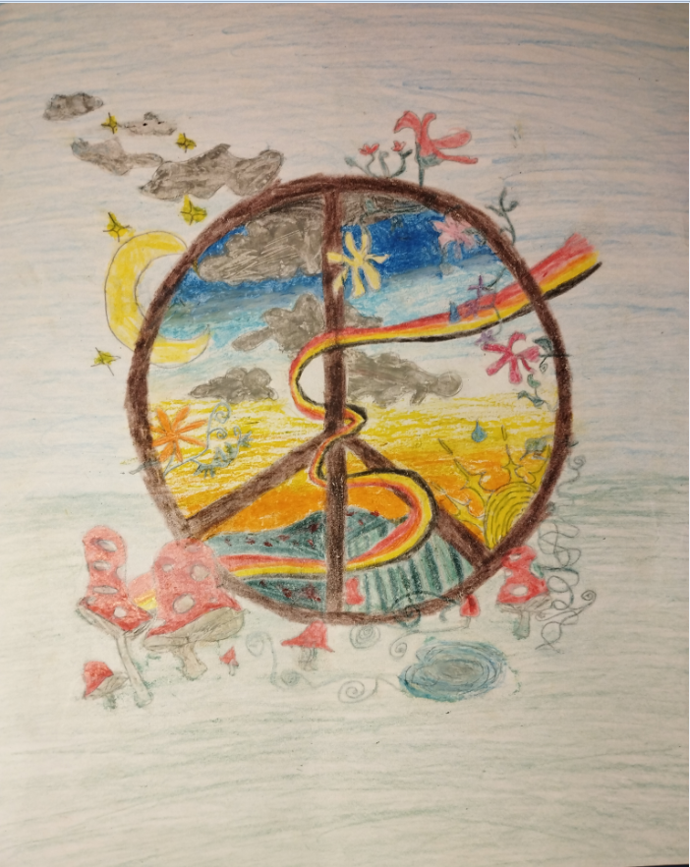

Picture made by Erissiana Mema

FOOD AND GOOD HEALTH
Do people tend to care about leading a healthy lifestyle! They don’t exercise, they eat unhealthy foods, which is terrible for their health and their life in the future. Many people believe that adding green vegetables to their diet is the only thing you need to be healthy. Unfortunately, that is not the case.
Firstly, I think that the food we consume is very significant for a good and healthy lifestyle. You must have a varied and balanced diet. Everyone’ s ideal diet is different, but it must include grains , fruits, vegetables, dairy , meat and of course meat. Also, if you have a medical problem, you may need to be very careful about what you eat. You mustn’t skip any of the three meals each day, because they give you energy.
Also, regular physical activity contributes to your wellbeing. Make sure that you exercise every day. Exercise boosts your mind, your energy and your health in general. You can do a lot of types of exercise that can keep you in good physical condition, like aerobics, jogging, cycling and you can participate in team sports with your friends, which could be more enjoyable.
Furthermore, sleep is perhaps the most important factor for a good life. Sleep maintains your immune system, your weight and your mental health. Try to wind down naturally around the same time every evening, so your body knows it’s time to relax. Teenagers may need around a 10 hour sleep, whereas an adult needs seven or eight hours of sleep, but may need to nap or spend more time in bed.
Lastly, relaxation is essential to your health. Engaging in hobbies that relax you , get you out of the house and walk in nature , hang out with your friends are some great ideas , in combination to a healthy, balanced diet.
ZOE BIHTA C5

Front cover designed by Melina Maggoufi
Back cover designed by Konstantina Rokka

